**Project Design Phase-II**

**Data Flow Diagram & User Stories**

|  |  |
| --- | --- |
| Date | 22 June 2025 |
| Team ID | LTVIP2025TMID35598 |
| Project Name | Smart Sorting: Transfer Learning for Identifying Rotten Fruits and Vegetables |
| Maximum Marks | 4 Marks |

**Data Flow Diagrams:**

Smart Sorting system using transfer learning to detect rotten produce. It outlines the key components—image input, preprocessing, feature extraction via a pre-trained CNN (like VGG16), classification, and actionable sorting decisions.

Let me know if you'd like the diagram to emphasize any particular aspect, such as integration with Flask or front-end feedback loops!

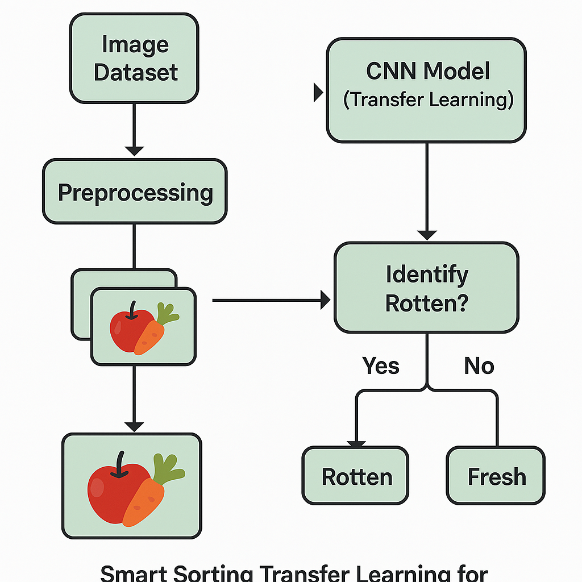

**Example: DFD Level 0 for smart sorting**

**User stories:**

| **User Type** | **Epic** | **Story #** | **User Story** | **Acceptance Criteria** | **Priority** | **Release** |
| --- | --- | --- | --- | --- | --- | --- |
| **Farmer/Vendor** | **Registration** | **SS-US-1** | **Register with email and password.** | **Can log in after registering.** | **High** | **Sprint-1** |
| **Farmer/Vendor** | **Image Upload** | **SS-US-2** | **Upload images of produce for analysis.** | **System accepts and confirms upload.** | **High** | **Sprint-2** |
| **Farmer/Vendor** | **Prediction** | **SS-US-3** | **View prediction of freshness or spoilage.** | **See label and confidence score.** | **High** | **Sprint-2** |
| **Farmer/Vendor** | **View History** | **SS-US-4** | **View history of uploaded images and results.** | **Records show date and outcome.** | **Medium** | **Sprint-3** |
| **Admin** | **Manage Users** | **SS-US-5** | **Manage registered users (view/edit/delete).** | **Admin panel lists users with action buttons.** | **Medium** | **Sprint-3** |
| **Admin** | **Model Feedback** | **SS-US-6** | **Review feedback and retrain the model as needed.** | **Can access feedback and start retraining.** | **High** | **Sprint-4** |